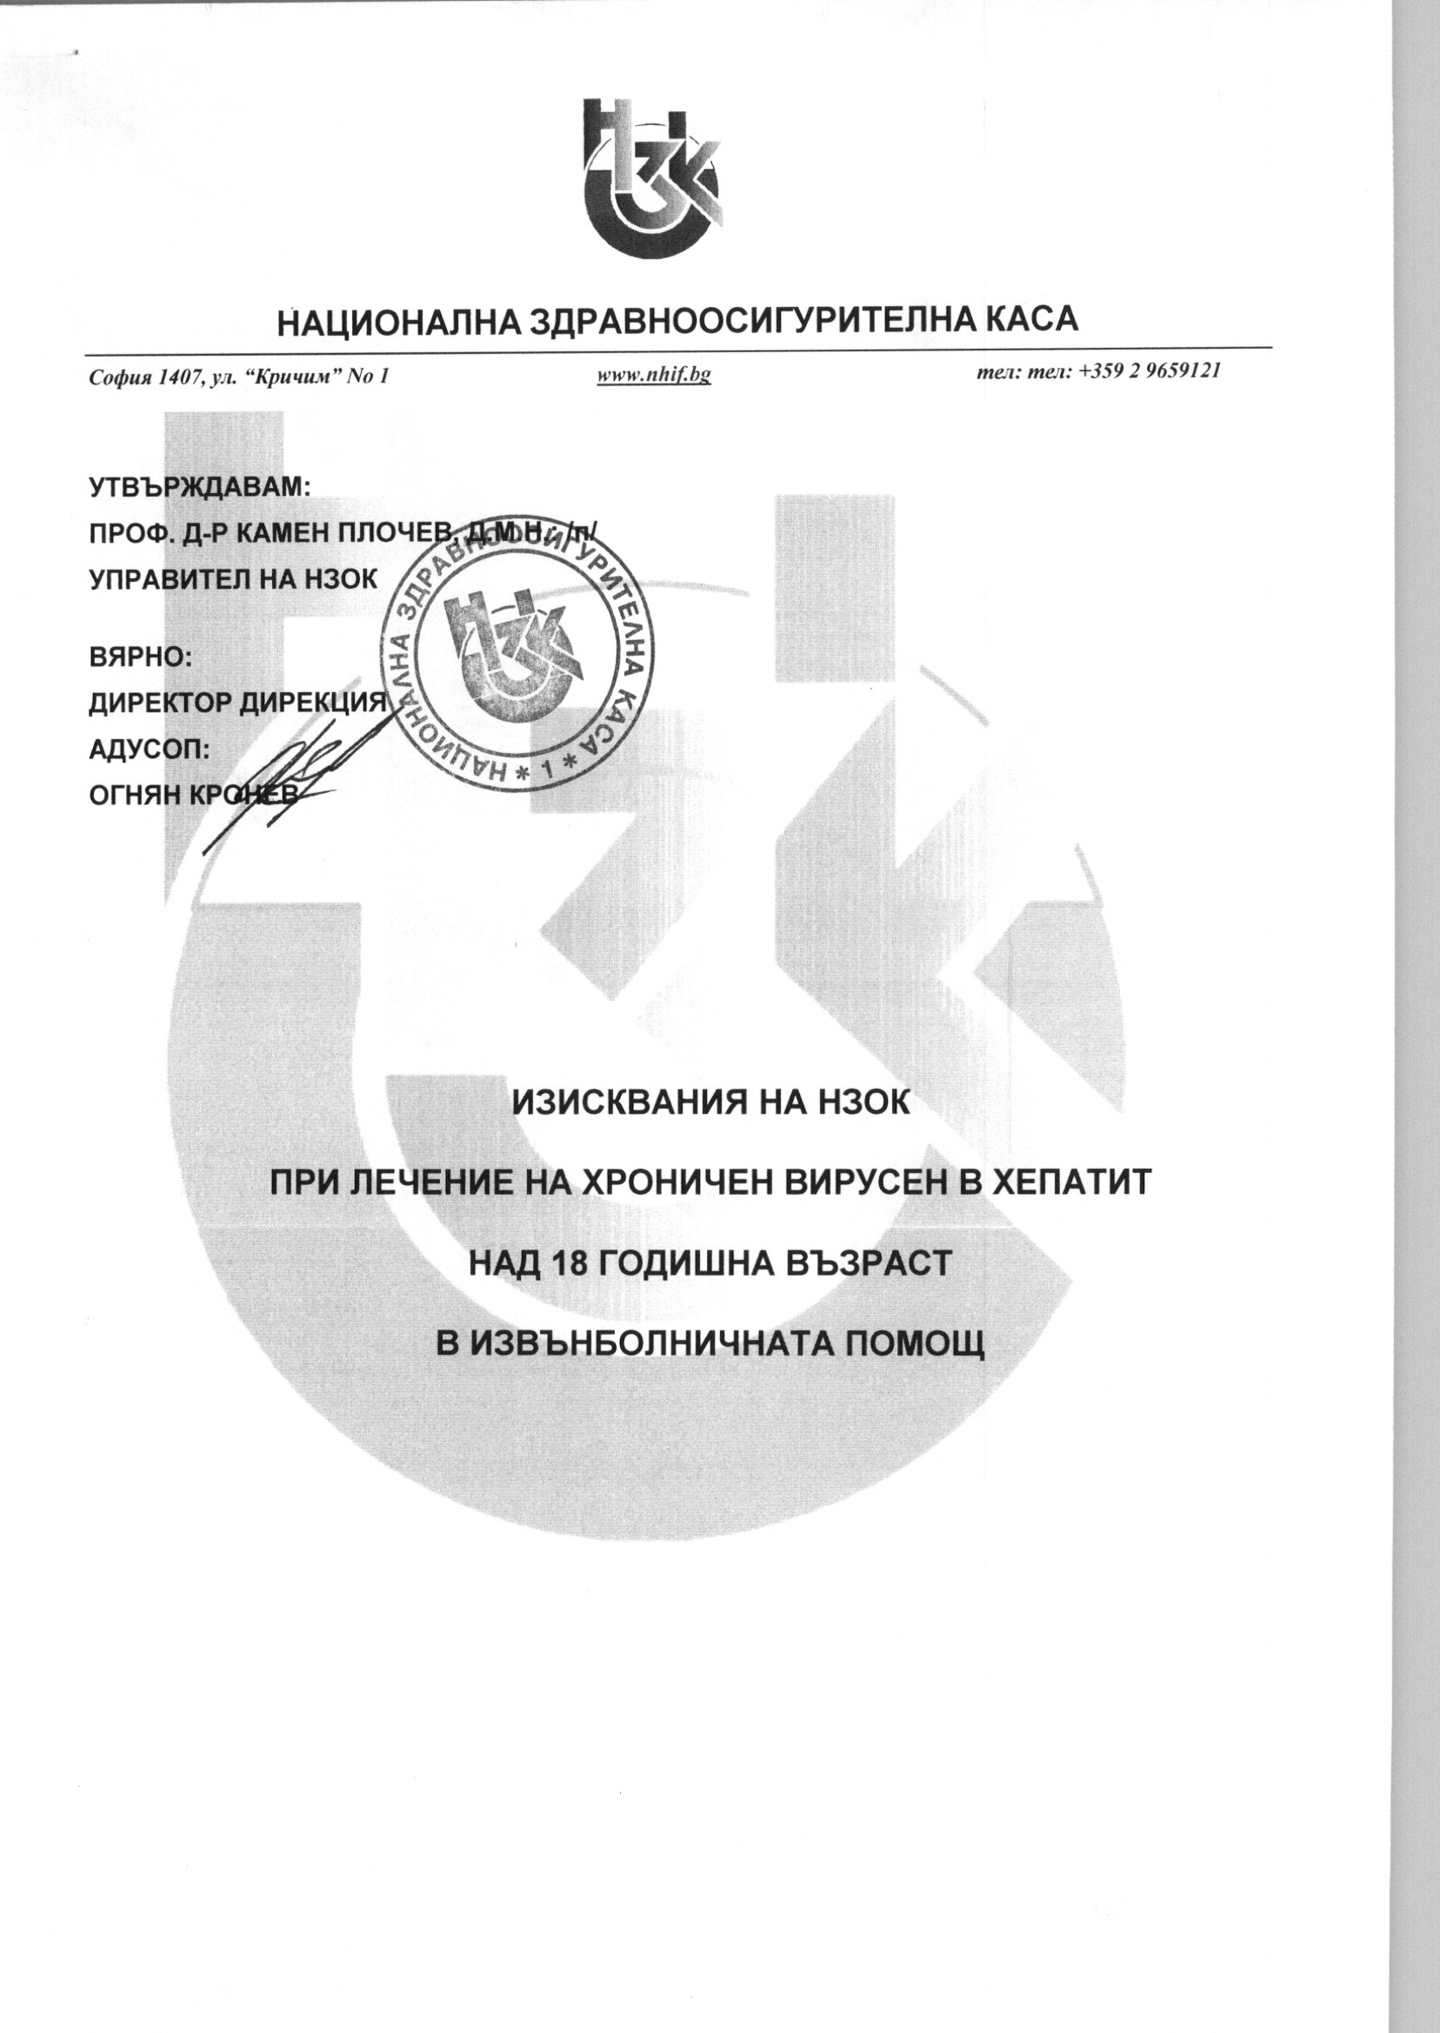

C:\Users\aangelova\AppData\Local\temp\EDOCS.C203D4CC\00132102.FA3DC2F1\002F6A41.tif

C:\Users\aangelova\AppData\Local\temp\EDOCS.C203D4CC\00132102.FA3DC2F1\002F6A42.tif

C:\Users\aangelova\AppData\Local\temp\EDOCS.C203D4CC\00132102.FA3DC2F1\002F6A43.tif

C:\Users\aangelova\AppData\Local\temp\EDOCS.C203D4CC\00132102.FA3DC2F1\002F6A44.tif

C:\Users\aangelova\AppData\Local\temp\EDOCS.C203D4CC\00132102.FA3DC2F1\002F6A45.tif

C:\Users\aangelova\AppData\Local\temp\EDOCS.C203D4CC\00132102.FA3DC2F1\002F6A46.tif

C:\Users\aangelova\AppData\Local\temp\EDOCS.C203D4CC\00132102.FA3DC2F1\002F6A47.tif

C:\Users\aangelova\AppData\Local\temp\EDOCS.C203D4CC\00132102.FA3DC2F1\002F6A48.tif