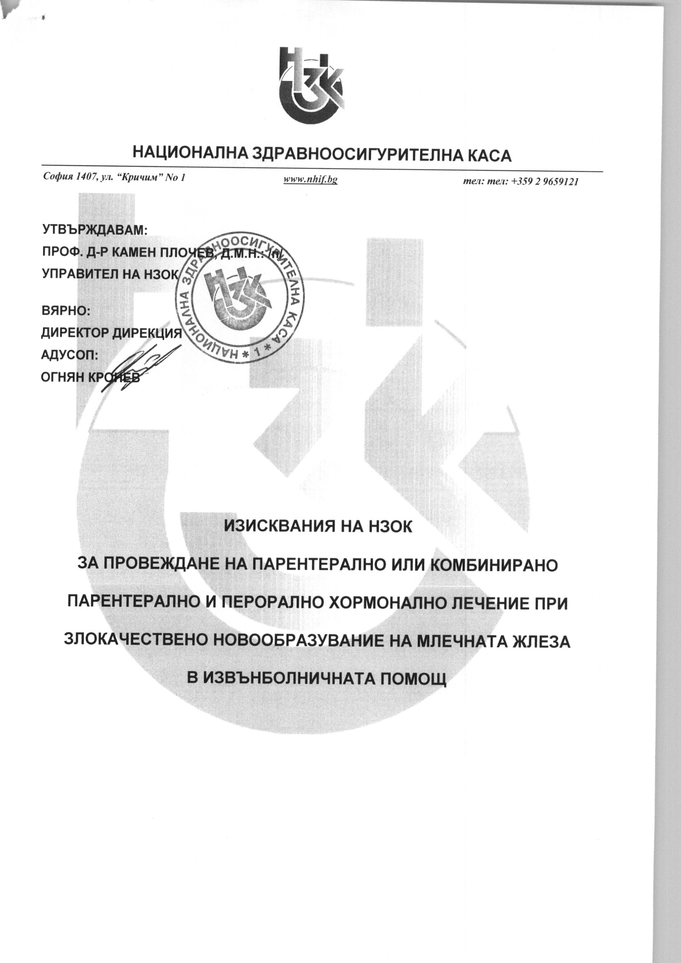

C:\Users\aangelova\AppData\Local\temp\EDOCS.C203D4CC\00132102.FA3DC2F1\002F6A2C.tif

C:\Users\aangelova\AppData\Local\temp\EDOCS.C203D4CC\00132102.FA3DC2F1\002F6A2D.tif

C:\Users\aangelova\AppData\Local\temp\EDOCS.C203D4CC\00132102.FA3DC2F1\002F6A2E.tif

C:\Users\aangelova\AppData\Local\temp\EDOCS.C203D4CC\00132102.FA3DC2F1\002F6A2F.tif

C:\Users\aangelova\AppData\Local\temp\EDOCS.C203D4CC\00132102.FA3DC2F1\002F6A30.tif

C:\Users\aangelova\AppData\Local\temp\EDOCS.C203D4CC\00132102.FA3DC2F1\002F6A31.tif

C:\Users\aangelova\AppData\Local\temp\EDOCS.C203D4CC\00132102.FA3DC2F1\002F6A32.tif

C:\Users\aangelova\AppData\Local\temp\EDOCS.C203D4CC\00132102.FA3DC2F1\002F6A33.tif

C:\Users\aangelova\AppData\Local\temp\EDOCS.C203D4CC\00132102.FA3DC2F1\002F6A34.tif